

**Chapter 05: Implementation of Sorting Algorithms**

HND CSD

BCAS Campus, Kalmunai

By: Eng. A.L. Jubailah Begum

data structures & algorithms

Bubble Sort

Bubble Sort is the simplest sorting algorithm that works by repeatedly swapping the adjacent elements if they are in wrong order.

Following is the implementation of Bubble Sort.

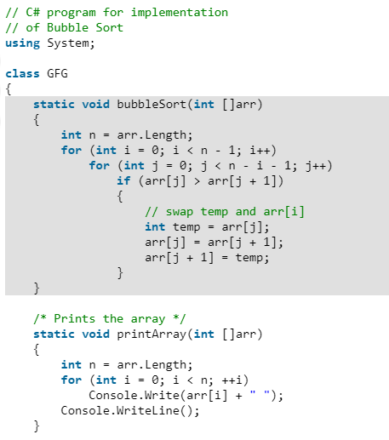

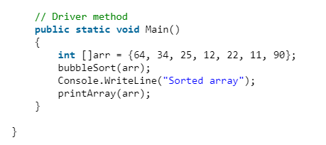

Illustration for the code:

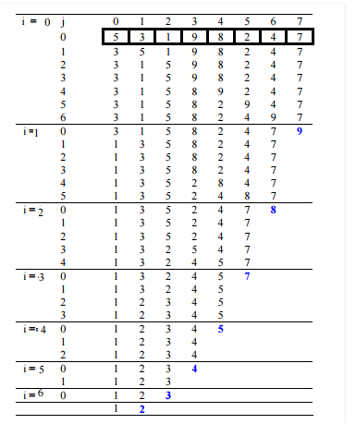

# Selection Sort

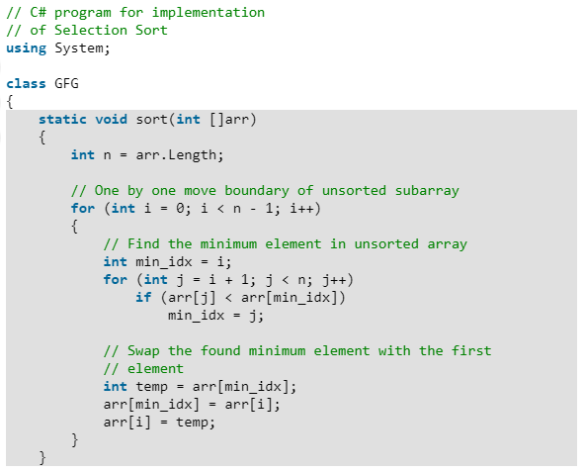

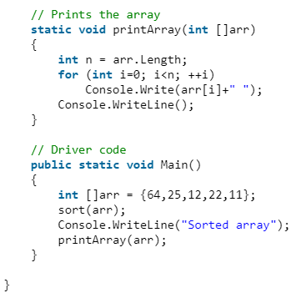

# Insertion Sort

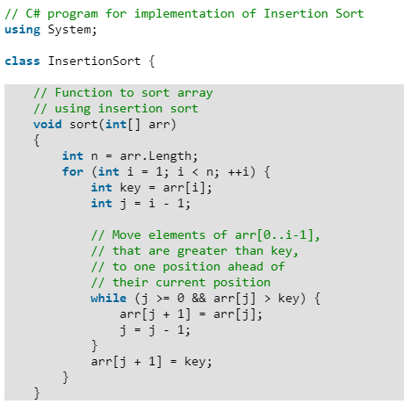

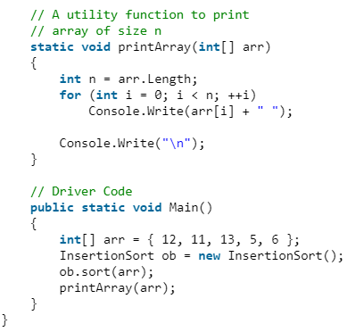

# Quick Sort

# Following is the implementation of Quick sort.

